STATEMENT
Some time ago I was informed by a senior human rights attorney, Richard Spoor, that in his view former South African attorneys, Ronald Bobroff and Darren Bobroff, had been unfairly dealt with by the media.
I have examined the document attached hereto, which contains details of allegations made against the Bobroffs and also the refutation of such allegations, and have had regard to the links supporting the refutation.
In my considered view, with 57 years of experience of litigation, the links establish the truth of the refutation overwhelmingly on the probabilities.
I have acted throughout pro bono in this matter, and am concerned here only with the cause of justice, to which I have dedicated much of my life.

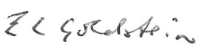
E.L Goldstein
3 December 2024

