

prelim report

REQUEST

A request was received to conduct surveillance on Mr. Jacob Serobe to establish his where about’s and daily activities.

FEEDBACK

The following feedback can be supplied in this regard:

Wednesday 19th October 2011:

The investigators traced Mr. Serobe to Stand 7713, Camelthorn Street, Roodebult, Germiston area.

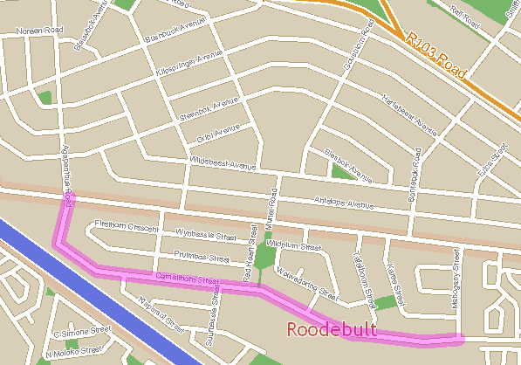

Map of the area.

Directions to the residence:

Take N3 towards Durban

Take Heidelberg Avenue offramp from the N3, turn left at robot

Becomes Nederveen Street

Turn right into Agapanthus Street

Drive to T junction with Reedbok Avenue.

Turn left into Reedbok Ave and immediately left into Camelthorn
Road

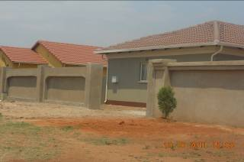

Photo of the premises

14:30 The investigator observed that the subject left the premises on foot and went to the first Spaza shop down the road and asked for airtime, then left to a second Spaza shop.

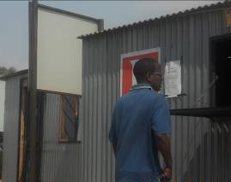

Photo of the subject at the first spaza shop

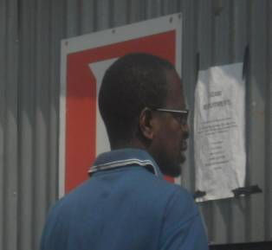
Close up Photo of the subject.

14:33 The subject arrived at the second Spaza shop and bought a Vodacom recharge voucher worth R30.

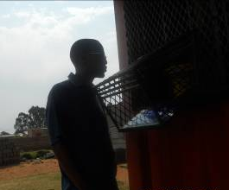

Photo of the subject at the second Spaza shop.

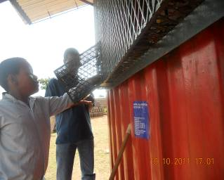

Photo of the subject counting “loose change” to buy airtime.

14:37 The subject returned to the premises.

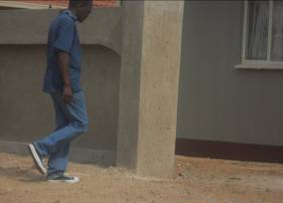

Photo of the subject entering the premises.

No further movements were observed of the subject or anybody else at the premise.

